**ALGORITHM (30 points)**

Display welcome screen

Get input for number_of_students

while number_of_students is not a numeric value:

Display error message

Get input for number_of_students

Else:

Set study_hours_sum to 0

Set credits_sum to 0

Set i to 0

While i < number_of_students:

Get input for first name

Get input for last name

Get input for credits

while credits is not integer OR credits % 3 is not 0:

display invalid input

Get input for credits

Get input for grade and convert to uppercase

While grade in not valid:

display invalid input

Get input for grade and convert to uppercase

Num_of_classes = credits / 3

Num of hours = 0

if grade == "A":

num_of_hours = 15

elif grade == "B":

num_of_hours = 12

elif grade == "C":

num_of_hours = 9

elif grade == "D":

num_of_hours = 6

total_hours = num_of_classes * num_of_hours

credits_sum += credits

study_hours_sum += total_hours

Display student details

END WHILE

Display total students

Display average credits

Display average study hours

**VARIABLES/CONSTANTS (5 points)**

Num_of_stds (Int)

Study_hours_sum (Int)

Credits_sum (Int)

First_name (String)

Last_name (String)

Credits (Int)

Grade (String)

Num_of_classes (Int)

Num_of_hours (Int)

Total_hours (Int)

**FORMULAS (5 points)**

num_of_classes = credits / 3

total_hours = num_of_classes * num_of_hours

**TEST DATA – 5 complete data sets (10 points)**

You can place in Excel file if you embed into Word and submit the Excel file

Remember to test for invalid data such as entering an L for the letter grade

|  |  |  |
| --- | --- | --- |
| **Input (Use variable names)** | **Process (Formula)** | **Output (Expected Results)** |
| first_name = John  last_name = Smith  credits = 9  grade = A | num_of_classes = 9 / 3 = 3  num_of_hours = 15  total_hours = 3 * 15 = 45 | Name: John Smith  Credits: 9  Study Hours: 45  Grade: A |
| first_name = Carl  last_name = Jemis  credits = 6  grade = B | num_of_classes = 6 / 3 = 2  num_of_hours = 12  total_hours = 2 * 12 = 24 | Name: Carl Jemis  Credits: 6  Study Hours: 24  Grade: B |
| first_name = Mary  last_name = Christina  credits = 12  grade = C | num_of_classes = 12 / 3 = 4  num_of_hours = 9  total_hours = 4 * 9 = 36 | Name: Mary Christina  Credits: 12  Study Hours: 36  Grade: C |
| first_name = Johnson  last_name = Charles  credits = 3  grade = L |  | Invalid grade |
| first_name = Johnson  last_name = Charles  credits = 3  grade = F | num_of_classes = 3 / 3 = 1  num_of_hours = 0  total_hours = 1 * 0 = 0 | Name: Johnson Charles  Credits: 3  Study Hours: 0  Grade: F |

**FLOWCHART (20 points submit separate Visio flowchart file)**

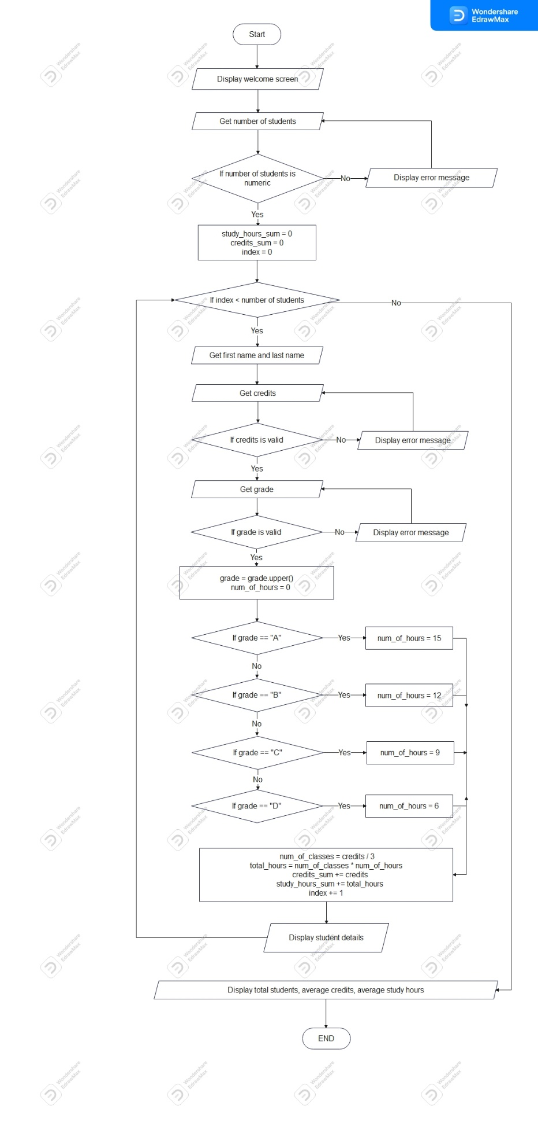

**PYTHON CODE (submitted in separate file and copied below) (30 points)**

# Display welcome screen

print("---------------------------------------------------")

print(" WELCOME")

print("---------------------------------------------------")

# Get input for number of students

num_of_stds = input("\nEnter number of students you want to process : ")

# Validate input

while not num_of_stds.isnumeric():

print("Number of students must be an integer")

num_of_stds = input("Enter number of students you want to process : ")

# Convert to an integer value

num_of_stds = int(num_of_stds)

study_hours_sum = 0

credits_sum = 0

# Iterate through each student

for i in range(num_of_stds):

# Get input for name

first_name = input("\nEnter first name : ").capitalize()

last_name = input("Enter last name : ").capitalize()

# Get input for number of credits

while True:

try:

credits = int(input("Number of credits : "))

# Check whether it is an multiple of 3

while credits % 3 != 0:

print("Number of credits must be a multiple of 3")

credits = int(input("Number of credits : "))

break

# If it is not an integer display error message and get input again

except:

print("Number of credits must be an positive integer")

# Get input for grade and validate

grade = input("Enter the grade that you want : ").upper()

while grade not in ["A", "B", "C", "D", "F"]:

print("Invalid grade")

grade = input("Enter the grade that you want : ").upper()

# calculate number of classes

num_of_classes = credits / 3

# Determine number of study hours for 1 class

num_of_hours = 0

if grade == "A":

num_of_hours = 15

elif grade == "B":

num_of_hours = 12

elif grade == "C":

num_of_hours = 9

elif grade == "D":

num_of_hours = 6

# Determine number of study hours for all classes

total_hours = num_of_classes * num_of_hours

# Calculate summation of total credit and total study hours

credits_sum += credits

study_hours_sum += total_hours

# Display student details

print(f"\nName: {first_name} {last_name}\n"

f"Credits: {credits}\n"

f"Study Hours: {round(total_hours)}\n"

f"Grade: {grade}")

# Display all students summary

print(f"\nTotal Students: {num_of_stds}\n"

f"Average Credits: {round(credits_sum / num_of_stds, 2)}\n"

f"Average Study Hours: {round(credits_sum / num_of_stds, 2)}")

**TEST DATA EXECUTION RESULTS (up to a 15 point deduction)**



